**Flood Fill algorithm**

Sometimes we want to fill an area that is not defined within a single color boundary. We paint such areas by replacing a specified interior color instead of searching for a boundary color value. This approach is called a flood-fill algorithm.

1. We start from a specified interior pixel (x, y) and reassign all pixel values that are currently set to a given interior color with the desired fill color.

2. If the area has more than one interior color, we can first reassign pixel values so that all interior pixels have the same color.

3. Using either 4-connected or 8-connected approach, we then step through pixel positions until all interior pixels have been repainted.

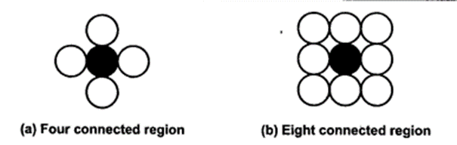

**Procedure -**

flood_fill (x, y, old_color, new_color)

{

if (getpixel (x, y) = = old_colour)

{

putpixel (x, y, new_colour);

flood_fill (x + 1, y, old_colour, new_colour);

flood_fill (x - 1, y, old_colour, new_colour);

flood_fill (x, y + 1, old_colour, new_colour);

flood_fill (x, y - 1, old_colour, new_colour);

flood_fill (x + 1, y + 1, old_colour, new_colour);

flood_fill (x - 1, y - 1, old_colour, new_colour);

flood_fill (x + 1, y - 1, old_colour, new_colour);

flood_fill (x - 1, y + 1, old_colour, new_colour);

}

}

**Program:**

#include<stdio.h>

#include<conio.h>

#include<graphics.h>

#include<dos.h>

void floodFill(int x,int y,int newcolor,int oldcolor)

{

if(getpixel(x,y) == oldcolor)

{

putpixel(x,y,newcolor);

delay(10);

floodFill(x+1,y,newcolor,oldcolor);

floodFill(x,y+1,newcolor,oldcolor);

floodFill(x-1,y,newcolor,oldcolor);

floodFill(x,y-1,newcolor,oldcolor);

floodFill(x-1,y-1,newcolor,oldcolor);

floodFill(x-1,y+1,newcolor,oldcolor);

floodFill(x+1,y-1,newcolor,oldcolor);

floodFill(x+1,y+1,newcolor,oldcolor);

}

}

void main()

{

int gm,gd=DETECT,radius;

int x,y;

initgraph(&gd,&gm,"..\\BGI");

printf("Enter x and y positions for circle\n");

scanf("%d%d",&x,&y);

printf("Enter the radius of circle\n");

scanf("%d",&radius);

circle(x,y,radius);

floodFill(x,y,3,15);

getch();

closegraph();

}

**Output:** 

**Output:** Comment on

1. Importance of Flood fill
2. Limitation of methods
3. Usefulness of method